**Assignment - 2**

**1.Generate Crypto Material for 2 Organizations with 2 peers each:**

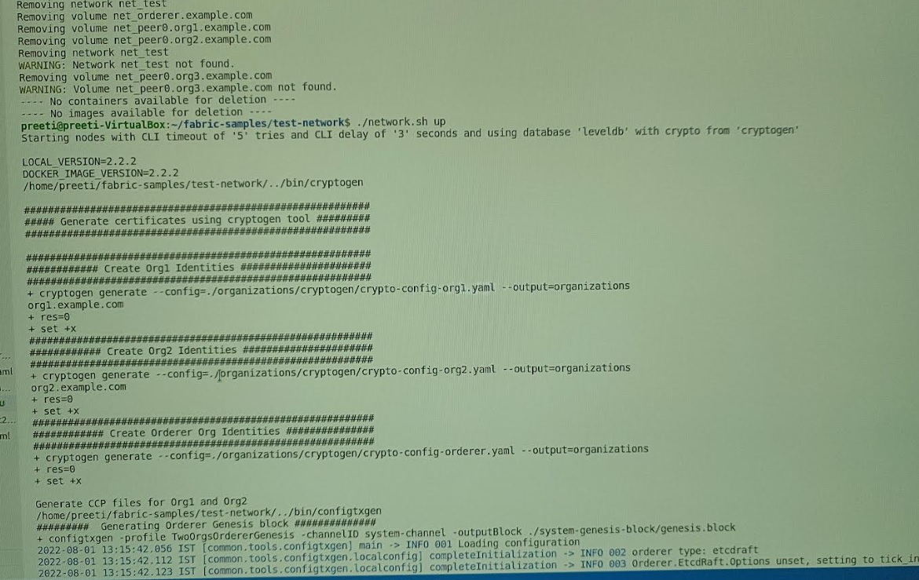

**2.Generate Genesis file for the generated cryptomaterial**

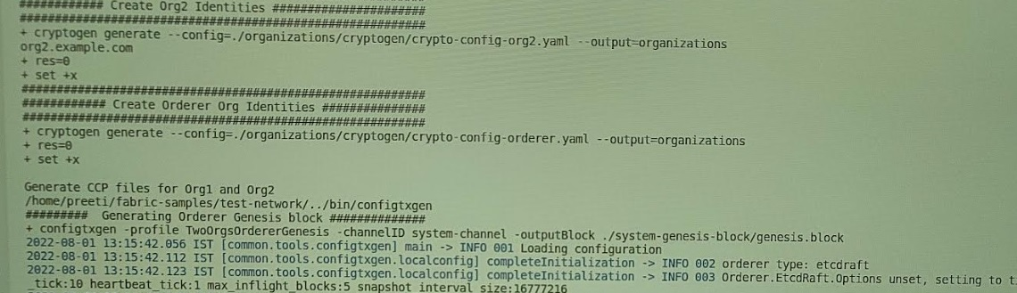

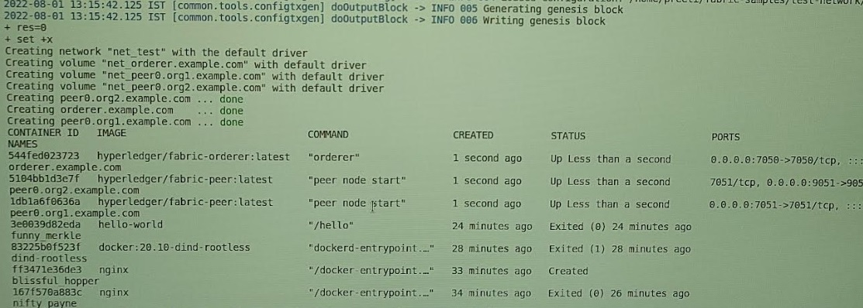

**3.Generate channel.tx file with channel name as mychannel**

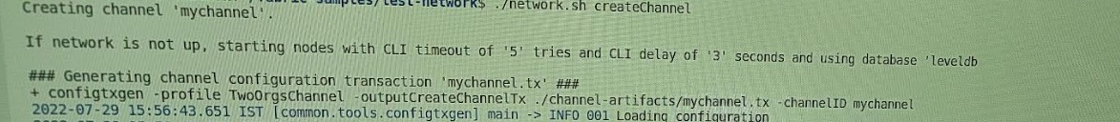

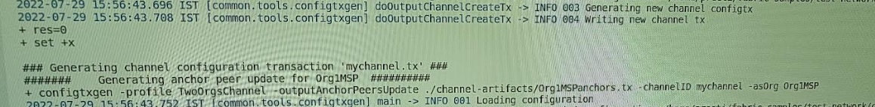

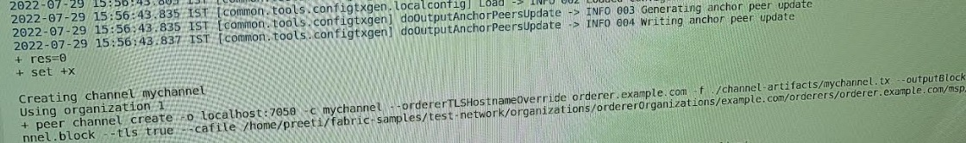

**4.Generate anchor peer tx files**



**5.Start the Blockchain network with the previously generated artifacts**

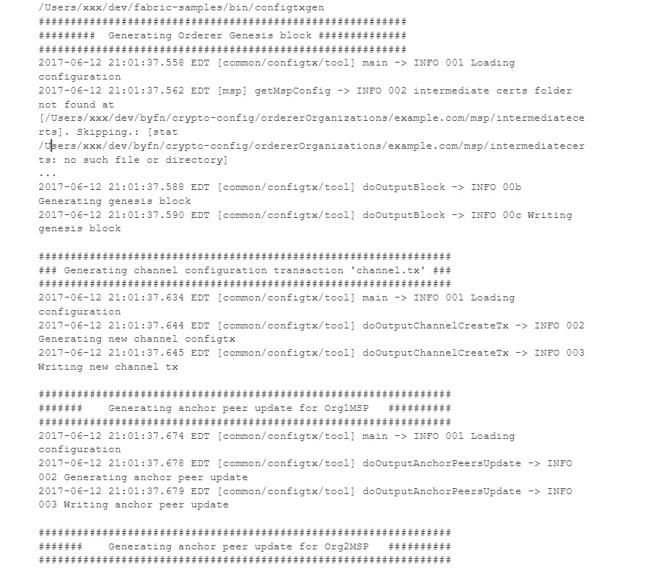

**6.Create a new channel with the name “mychannel”**

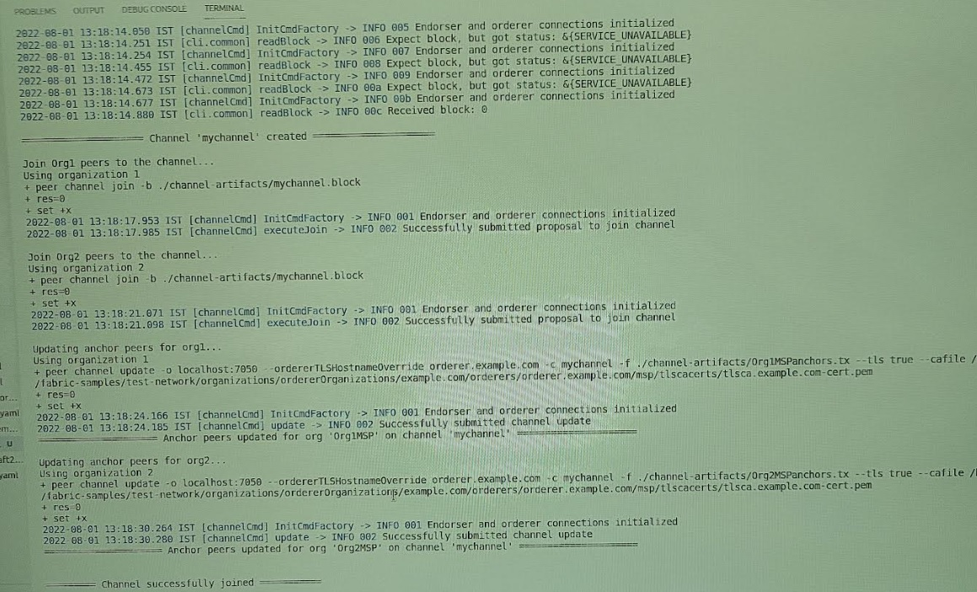

**7.Join the Peers of both organizations into the newly created channel:**

**​mychannel**

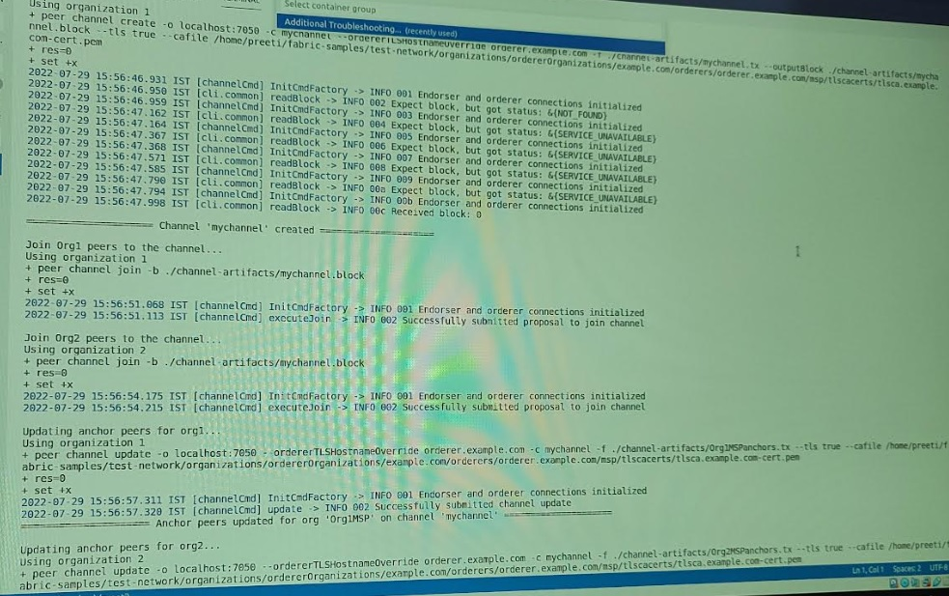

**8.Join the anchor peers of both organizations into the newly created channel:mychannel**



**9.Install the chaincode on all organization peers:**

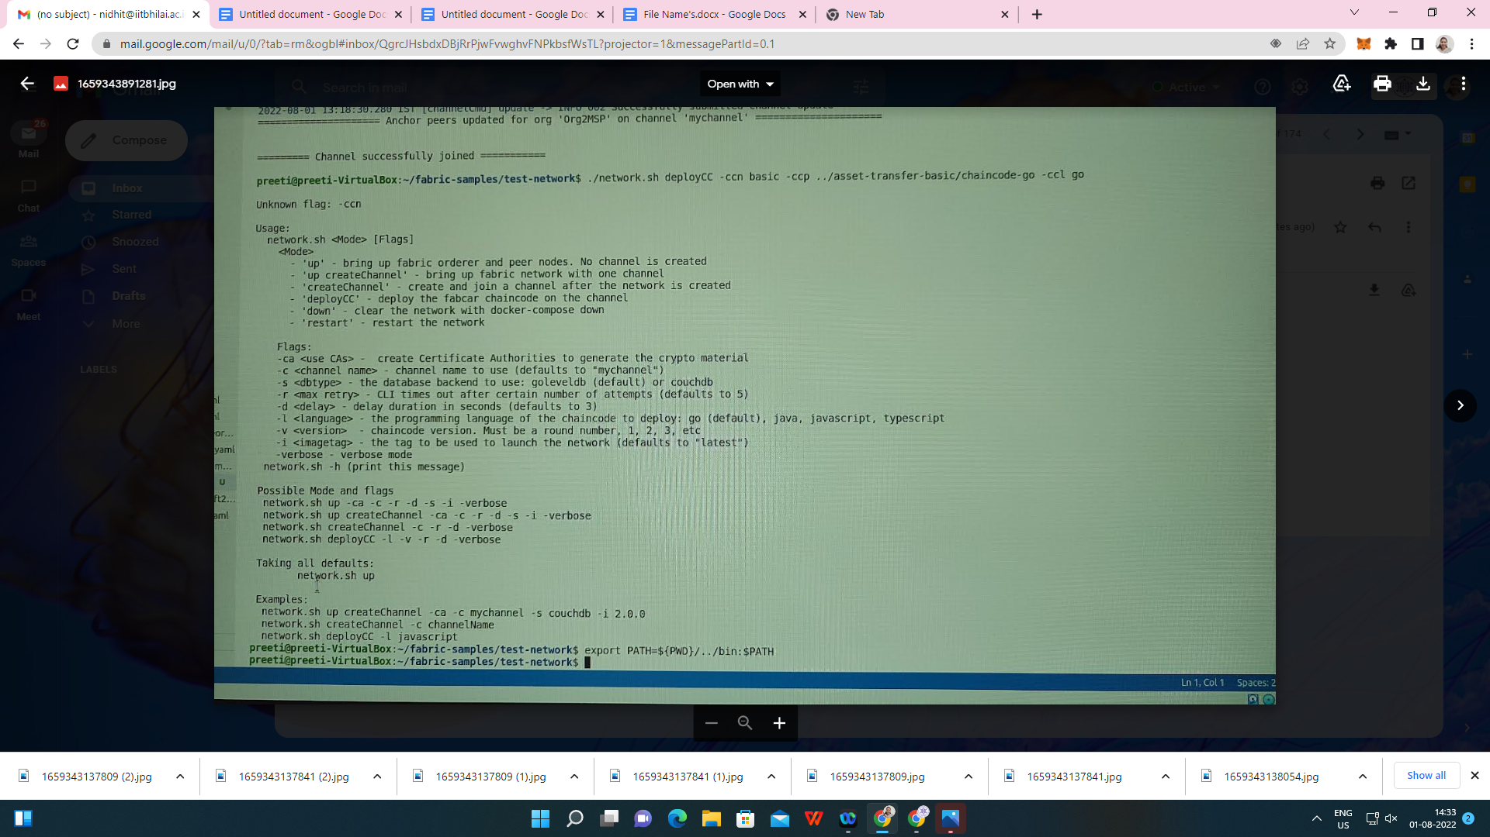

**10.Instantiate the chaincode on peer0 of 1st organization.**

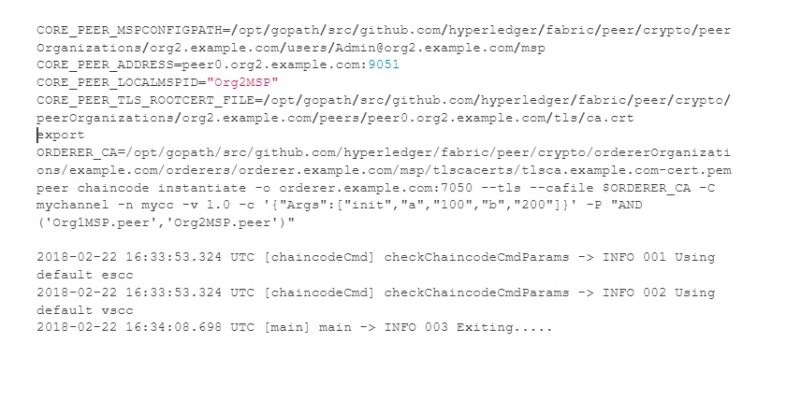

**11.Perform a Query operation on the Blockchain network to retrieve the balance of A&B accounts**

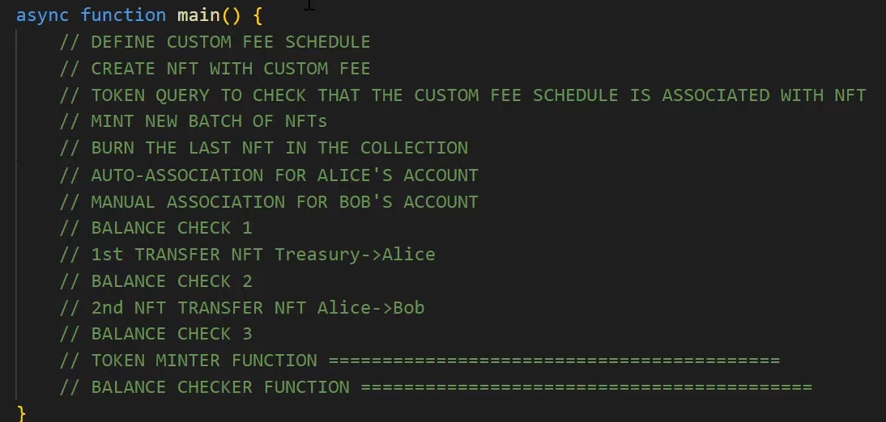

**12.Invoke a transaction in Blockchain network for transferring the balance from one account to other**

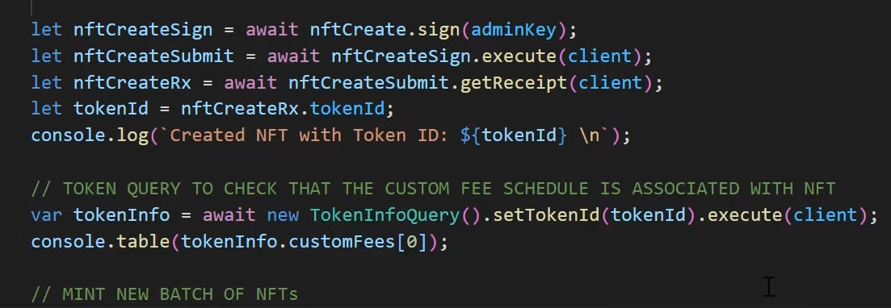

**13. Perform a Query operation on the Blockchain network to retrieve the updated balance of A&B accounts**



**14. Stop the Blockchain network**

